

**Title:**

**Enhancing Fake Review Detection with Cross-Platform Analysis Using Supervised and Deep Learning Models and Feature Engineering Evaluation**

Faryad Bigdeli

**Master’s project**

**Abstract**

The prevalence of fake reviews on online platforms poses a significant challenge to maintaining consumer trust and ensuring fair competition. This project aims to enhance fake review detection by developing and evaluating supervised and deep learning models within a cross-platform context. A unique dataset was constructed by merging five distinct datasets, and various features were engineered to improve the models' predictive capabilities. The study applied advanced preprocessing techniques, including text normalization and feature extraction, followed by model training using algorithms such as Logistic Regression, SVM, KNN, Random Forest, LSTM, CNN-LSTM, and LSTM-RNN.

The results demonstrated that while deep learning models are powerful in capturing complex patterns, simpler supervised models, particularly SVM, showed superior performance in detecting fake reviews within the dataset used. The utility of feature engineering was found to be dependent on the specific model and dataset, and it is not always beneficial. Additionally, testing with new and unseen data confirmed the models' generalizability, and simulated user feedback showed their adaptability to evolving input data. This study underscores the importance of context-specific model selection and highlights the continued relevance of supervised learning models in certain scenarios, particularly where dataset size and diversity are factors. The findings contribute to developing more reliable and adaptable fake review detection systems, offering insights for future research in this critical area.

**Table of contents**

1. **Introduction** 5

2. **Research** 7

2.1. **Literature Review** 7

2.2. **User Needs** 10

3. **Metadata** 10

4. **Exploratory Data Analysis** 13

5. **Methodology** 20

5.1. **Data Collection and Initial Exploration** 20

5.2. **Data Cleaning Process and Dataset Creation** 21

5.3. **Feature Extraction and Engineering** 22

5.4. **Dataset Preprocessing and Supervised Model Training** 23

5.5. **Performance Evaluation** 25

5.6. **Integration of Simulated User Feedback** 27

5.7. **Deep Learning Model Development** 27

6. **Results and Discussion** 29

6.1. **Performance Results of Supervised Models** 29

6.2. **Evaluating the Efficacy of Feature Engineering** 32

6.3. **Testing Supervised Models with New Data** 34

6.4. **Performance of Supervised Models after Retraining with Simulated User Feedback** 36

6.5. **Comparison of Deep Learning and Supervised Models** 38

7. **Conclusion** 40

8. **Future Work and Recommendations** 43

**Bibliography** 44

**Appendices** 47

**Appendix A: Project Evolution and Reflection**  47

**Table of figures**

**Figure 1) Distribution of Fake and Real Reviews in the Final Dataset** 11

**Figure 2) Distribution of rating for fake (left) and real (right) reviews** 14

**Figure 3) Word clouds for fake (left) and real (right) reviews** 15

**Figure 4) Boxplots for the distribution of stopwords, punctuation, and capitalization counts in fake and real reviews** 16

**Figure 5) Boxplots for the distribution of sentiment polarity and the ratio of repeating words in fake and real reviews** 17

**Figure 6) Boxplots for the distribution of text length and the FK score in fake and real reviews** 18

**Figure 7) Bar charts for total product name mention and average important words count in fake and real reviews** 20

**Figure 8) Framework for the proposed methodology** 21

**Figure 9) Top 10 most influential terms identified using a Random Forest classifier** 23

**Figure 10) Visualization of the performance metrics results for supervised models** 30

**Figure 11) Confusion matrix results for supervised models** 31

**Figure 12) Comparison of initial and test set F1 scores for the four supervised models** 35

**Figure 13) Bar charts of performance metrics for supervised models after incorporating simulated user feedback** 36

**Figure 14) Confusion matrix of supervised models after retraining with simulated user feedback data** 37

**Figure 15) Comparison of performance metrics for SVM and deep learning models** 38

**Table of tables**

**Table 1) Preprocessing Steps for Each Feature Type** 24

**Table 2) Cross-validation accuracy and optimal hyperparameters for supervised models** 29

**Table 3) Relative percentage change in model performance metrics after feature engineering** 32

**Table 4) Performance metrics of supervised models on the new test dataset.** 35

1. **Introduction**

The rise of online shopping has made consumer reviews pivotal in shaping purchasing decisions. However, the increasing prevalence of fake feedback, often posted by paid reviewers, compromises the authenticity of these reviews and poses a significant challenge to consumer trust. Given the critical role of reviews in influencing consumer choices, detecting fake reviews is essential to ensure fair competition and sustainable e-business practices. Despite considerable efforts over the past decade to distinguish genuine reviews from fake ones, significant challenges remain in areas such as cross-platform adaptability, the impact of feature engineering, the integration of user feedback, and the need for more complex methods like deep learning.

This project aims to bolster online consumer protection by developing multiple machine learning and deep learning models, including Logistic Regression (LR), Support Vector Machines (SVM), K-Nearest Neighbors (KNN), Random Forest (RF), Long Short-Term Memory (LSTM), Convolutional LSTM (CNN-LSTM), and LSTM Recurrent Neural Networks (LSTM-RNN). These models are specifically designed to detect and filter fake reviews. Subsequently, they underwent a comprehensive comparative analysis using metrics such as accuracy, precision, recall, and F1 score to determine their effectiveness.

In addressing the identified research gaps, this project focuses on the following key areas:

* Cross-Platform Adaptability: Developing models that perform consistently well across different e-commerce platforms, addressing the unique characteristics and diverse tactics used to generate fake reviews.
* Effect of Feature Engineering: Examining the impact of feature engineering on the performance of supervised models by comparing results from datasets with and without these engineered features. This analysis will help determine the necessity and effectiveness of feature engineering in improving model performance.
* Supervised vs. Deep Learning Approaches: Evaluating whether more advanced deep learning models offer significant benefits over traditional supervised methods. The project will compare the effectiveness of simpler machine learning algorithms with complex deep learning techniques to determine if the latter are necessary and more effective for detecting fake reviews.
* User Feedback Integration: Ensuring the system adapts and evolves with real-time user insights by simulating user feedback with a data sample to retrain models. This simulation aims to assess the models' adaptability with new data, mimicking real-world conditions where user feedback plays a role in model retraining.

Through these objectives, this project not only tackles critical challenges in digital commerce but also contributes to the development of more reliable and user-focused online communities.

This report is structured as follows: The literature review will discuss previous work on fake review detection, followed by the metadata chapter, which describes the datasets used in this study. Next, the exploratory data analysis (EDA) chapter will provide insights into the data through various visualizations. The methodology section will then outline the data collection and model development processes. Finally, the results and discussion sections will present the findings and their implications, leading to the conclusion and future work recommendations.

1. **Research**
   1. **Literature Review**

The issue of fake reviews significantly impacts consumer trust and decision-making, emphasizing the need for effective detection frameworks. Fake reviews can distort consumer perceptions, leading to misguided purchasing decisions and ultimately undermining the quality and integrity of e-commerce platforms. Researchers have extensively explored various methods to detect fake reviews, underscoring the critical need to enhance the accuracy and reliability of these systems (Abi Priya et al., 2020; Duma et al., 2024).

Current literature demonstrates the effectiveness of various machine learning models, including Logistic Regression, Random Forest, Support Vector Machine, and Naïve Bayes, in identifying fake reviews. Studies by Nguyen (2023), Sajid et al. (2023), and Mohawesh et al. (2021) highlight the success of these models in detecting fraudulent content. However, significant challenges remain, such as the need for large-scale, diverse datasets and the limitations of current methods in handling unbalanced data (Mewada and Dewang, 2022; Zaki et al., 2024). It is recommended that future research focus on aspect-based sentiment analysis, employing ensemble methods for improved detection, and addressing data imbalance issues to enhance the accuracy and reliability of detection systems. These studies collectively highlight the ongoing need for innovative approaches in combating fake reviews in the e-commerce space (Joghee, 2022; Salminen et al., 2022).

Another critical gap identified in the literature is the need for cross-platform detection capabilities. Many existing models are trained on datasets from a single e-commerce platform, limiting their generalizability. Alsubari et al. (2021) explored the detection of fake hotel reviews using supervised machine learning techniques, finding that Random Forest outperformed other models. However, the study noted the scarcity of large labeled datasets, highlighting a significant limitation in current research. Similarly, Soldner et al. (2022) found that detecting fake reviews is more challenging with cross-platform datasets due to additional variability and complexity. Their findings suggest that product ownership and data origin confound fake review detection, leading to overestimation of model performance when data is sourced from different platforms.

Based on the results by Soldner et al., models may perform well on single-platform datasets but struggle with cross-platform datasets due to the additional variability and complexity. Specifically, data origin boosts classification performance, which can be misattributed to veracity classification. Their findings suggest an overestimation of 24.89-46.23% when data is sourced from different platforms, indicating that detecting fake reviews is harder when the dataset is cross-platform. The authors emphasize the need for more rigorous experimental control in creating datasets for investigating complex concepts like deception.

Feature engineering plays a crucial role in enhancing the performance of fake review detection models. Nguyen (2023) proposed a machine learning framework for detecting fake reviews using text features and found that SVC was the most reliable. However, the study suggested exploring other feature extraction methods, like Bag of Words and Word2Vec, and considering deep learning approaches in future work.

Mohawesh et al. (2024) conducted an extensive survey on machine learning-based fake review detection and emphasized the challenge of obtaining labelled datasets. The study highlighted that traditional methods improve text classification through enhanced feature extraction, while deep learning models like LSTM achieve high accuracy through advanced presentation learning and algorithm structure. The study noted that many existing datasets, created through crowdsourcing, may not accurately represent real-world fake reviews. The authors emphasized the need for evaluating classifiers on real-world applications to develop more effective algorithms and identified gaps and future directions in the field.

Researchers also underscore the evolving complexity of fake review tactics, necessitating advanced detection methods. Salminen et al. (2022) pointed out that machine-generated fake reviews are becoming increasingly difficult for humans to identify, but machine learning classifiers can achieve near-perfect accuracy. This indicates that "machines can fight machines" in the battle against fake reviews. Wang et al. (2017) experimented with various learning algorithms, finding that neural networks outperformed other models in detecting fake reviews. These advancements highlight the need to compare traditional supervised models with new deep learning methods to determine the most effective approach for detecting fake reviews.

Recently, deep learning methods have been increasingly adopted in fake review detection research, with studies reporting their effectiveness (Qayyumet al., 2023; Mohawesh et al., 2024). Vyas et al. (2021) proposed a deep learning-based model using features such as word count, sentence length, sentiments, and N-grams, achieving promising results. Their preliminary results indicated that the LSTM-based approach has the potential to outperform existing machine learning methods. The authors suggest that, in the future, the implementation of their model could automate the detection of fake online customer reviews, serving as a unified model for identifying fake content.

Hajek et al. (2020) proposed two deep neural network models, which outperformed existing methods in accuracy and F-score, particularly for larger datasets with combined polarity. These findings suggest the potential of deep learning in enhancing fake review detection systems.

In summary, the literature on fake review detection has identified several effective machine learning methods but also highlighted significant gaps. Addressing these gaps will enhance the accuracy and reliability of fake review detection systems, ensuring a trustworthy online shopping experience for consumers.

* 1. **User Needs**

To facilitate the replication and further exploration of this project, the complete set of resources including all code, datasets, a project overview presentation, and the final report has been made in the GitHub repository below.

<https://github.com/f2-bigdeli/Fake-Review-Detection.git>

Users can access the repository to review the code used for data preprocessing, feature engineering, model training, and evaluation. The repository also contains the raw and processed datasets, allowing users to perform their own analyses or extend the research. A detailed README file is included in the repository, providing instructions on how to navigate the contents and utilize the resources.

1. **Metadata**

Initially, approximately 20 user review datasets were sourced from platforms such as GitHub and Kaggle. After thorough examination and web scraping, five datasets emerged as the only reliable, labelled, and unprocessed sources of user reviews available on public websites. These datasets were chosen for their structural compatibility and the presence of essential features like labels, which facilitated their integration. The focus was on using raw data to ensure originality in the analysis, deliberately excluding pre-processed datasets used in other studies.

These five datasets were subsequently merged to form a unique, comprehensive dataset that captures a diverse array of consumer feedback across various e-commerce platforms. The final merged dataset consists of 8 attributes and 7960 observations, with 1592 instances from each dataset, evenly split between 796 genuine and 796 fake reviews per dataset. This results in a balanced total of 3980 fake and 3980 real reviews, as depicted in Figure 1.

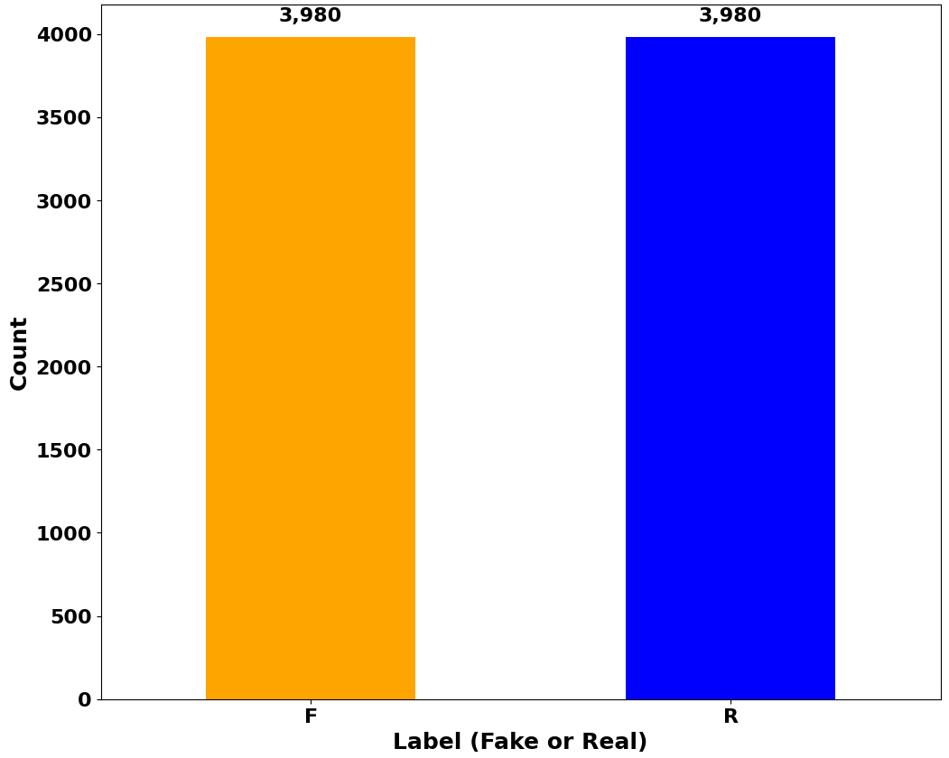

**Figure 1) Distribution of fake and real reviews in the final dataset**

Following feature engineering, the modified dataset expanded to 16 attributes, which were utilized in the modelling phase. The attributes are explained as follows:

* **PRODUCT_CATEGORY**: Represents the product category, encompassing 42 different categories, highlighting the dataset's cross-platform nature.
* **RATING**: Numerical rating given by users, ranging from 1 to 5.
* **LABEL**: Indicates the authenticity of the review, with 'F' for fake and 'R' for real.
* **REVIEW_TEXT**: The main text content of the review.
* **SOURCE**: The platform from which the review was sourced, such as Amazon, Yelp, Tripadvisor, or other sources.
* **VERIFIED_PURCHASE**: Denotes whether the purchase was verified ('Y' for yes, 'N' for no).
* **REVIEW_TITLE**: The title of the review.
* **TEXT_LENGTH**: The number of words in the review text.
* **SENTIMENT_POLARITY**: Sentiment polarity of the review text, ranging from -1 (negative) to 1 (positive).
* **PRODUCT_NAME_MENTION**: Indicates whether the product name is mentioned in the review text ('Y' for yes, 'N' for no).
* **IMPORTANT_WORDS_COUNT**: Counts the frequency of six predefined important words within each review.
* **RATIO_REPEATING_WORDS**: Proportion of words repeated more than once, indicating potential spam content.
* **STOPWORDS**: Number of stopwords in the review text.
* **FK_SCORE**: Flesch-Kincaid readability score of the review text.
* **CAPITALIZATION_COUNT**: Number of capitalized words in the review text.
* **PUNCTUATION_COUNT**: Number of punctuation marks in the review text.

1. **Exploratory Data Analysis**

After the feature engineering process, an exploratory data analysis (EDA) was conducted to investigate the relationships between the features in the dataset and the authenticity of the reviews. This analysis employed various visualization techniques to uncover potential patterns and insights.

To examine the distribution of review ratings in fake and real reviews, histograms were utilized. These histograms provided a clear view of how the review ratings were distributed, offering a straightforward method to identify any biases or patterns in the data.

Additionally, word clouds were generated for both fake and real reviews. These word clouds visually represented the significance of words and word co-occurrences, highlighting the most frequent terms in each category. This helped in identifying common themes and language patterns used in fake versus real reviews.

Box plots and bar charts were used to explore the possible relations between individual features and the authenticity of reviews. These visualizations helped in understanding how different features varied between fake and real reviews, providing initial insights into their predictive power.

One of the first steps in the exploration of the dataset involved visualizing the distribution of ratings for both fake and real reviews. Figure 2 shows the histograms generated for these two categories. The histograms reveal a striking similarity in their rating distributions. This observation suggests that fake reviews are crafted with a high level of sophistication, closely mirroring the patterns seen in genuine reviews.

This similarity in rating distributions highlights the challenge in detecting fake reviews based solely on rating metrics. The skilful replication of genuine review characteristics by fake reviews complicates the task of distinguishing between the two. Such tactics in fake review generation underscore the necessity for more advanced detection methods that go beyond superficial attributes like ratings.

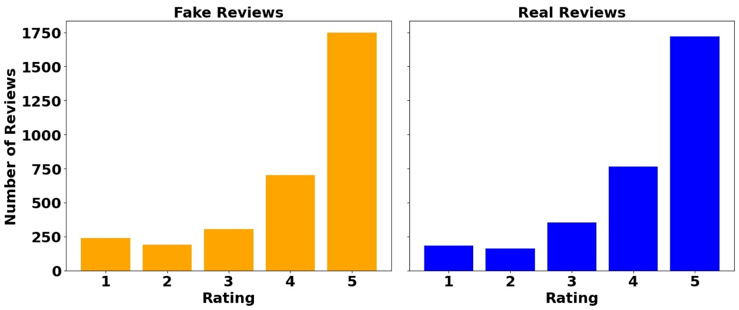

**Figure 2) Distribution of rating for fake (left) and real (right) reviews.**

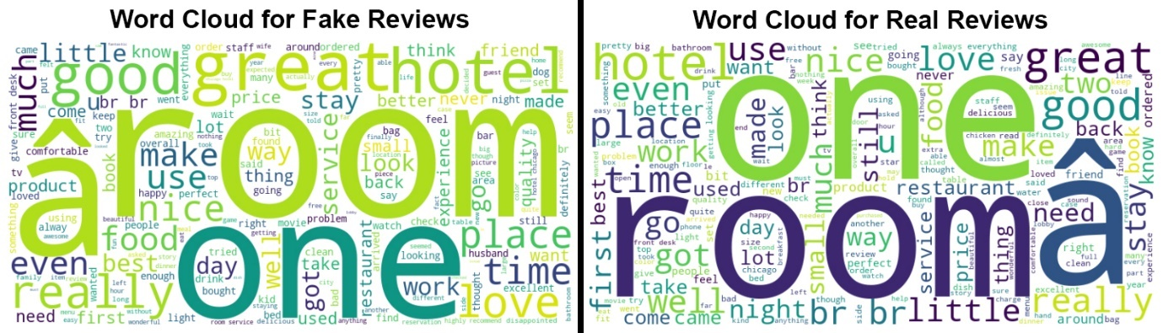

**Figure 3) Word clouds for fake (left) and real (right) reviews.**

Figure 3 represents generated word clouds for both fake and real reviews that visualize the most frequently used terms in each category. The resulting word clouds reveal that the terms in fake and real reviews are remarkably similar, further emphasizing the challenge in differentiating between the two types based solely on word frequency.

The close resemblance of the word clouds suggests that fake reviews are carefully crafted to use language that closely mimics genuine reviews. This makes distinguishing fake reviews through simple textual analysis difficult. Common terms in both categories, such as "great", "love", "really", and "good," appear with similar prominence, indicating that fake reviews often employ the same terminology as real reviews to appear authentic.

The word cloud analysis highlights the necessity for effective, multi-faceted review detection strategies to overcome the deceptive tactics used in fake review generation. Basic text analysis and keyword frequency alone are inadequate for effectively identifying fake reviews.

The evidence from these initial visualizations indicates that fake reviews are designed to blend seamlessly with real ones, making the detection process more intricate and demanding. Therefore, it is crucial to employ comprehensive analytical techniques incorporating diverse features and advanced algorithms to identify and filter out fake reviews effectively.

Figure 4 demonstrates the boxplots for stopwords, punctuation, and capitalization features. These boxplots analysis reveals a higher range of occurrences in real reviews compared to fake ones. This pattern suggests that real reviews tend to exhibit more conversational and less curated language, which may be indicative of genuine user experiences.

Higher occurrences of stopwords in real reviews imply a more natural and flowing writing style, as genuine reviewers are likely to write in a manner similar to everyday speech. Similarly, the increased use of punctuation and capitalization in real reviews points to a more expressive and less formulaic approach to writing.

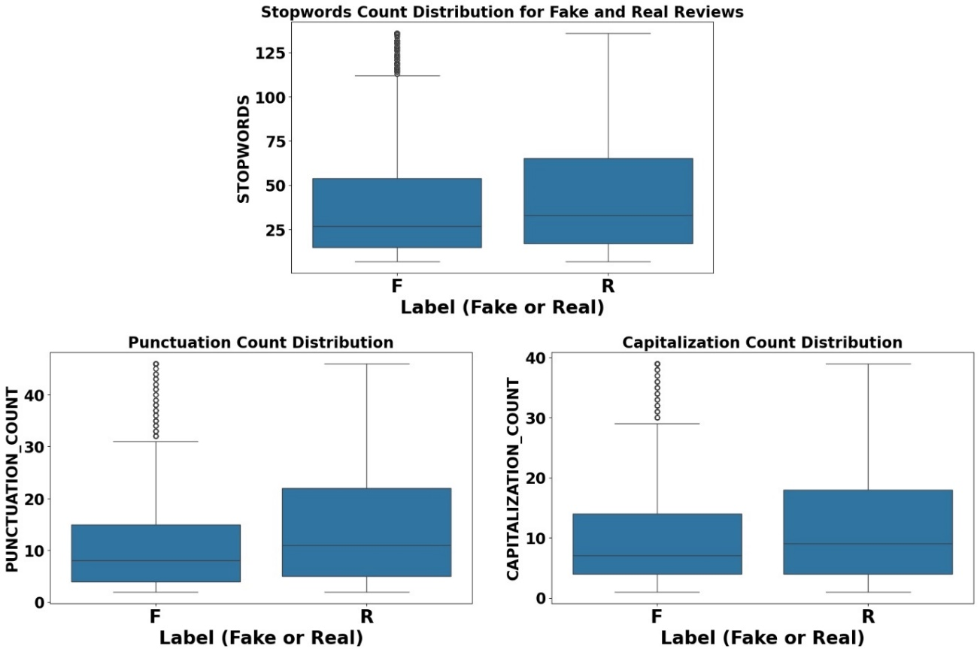

**Figure 4) Boxplots for the distribution of stopwords, punctuation, and capitalization counts in fake and real reviews.**

In contrast, fake reviews appear to be more polished and structured, potentially lacking the nuanced language patterns found in authentic reviews. This difference in linguistic features can serve as an important clue in distinguishing between fake and real reviews, even though it may not be definitive on its own.

These findings highlight the importance of considering a variety of linguistic features in the detection process. The trend of higher stopwords, punctuation, and capitalization in real reviews suggests that these elements can be valuable indicators of genuine user experiences.

The boxplot analysis for sentiment polarity and the ratio of repeating words reveals a higher range for these features in fake reviews compared to real ones (Figure 5). This trend suggests that fake reviews may employ deliberate repetition of positive sentiments or key phrases to artificially enhance the review's perceived authenticity.

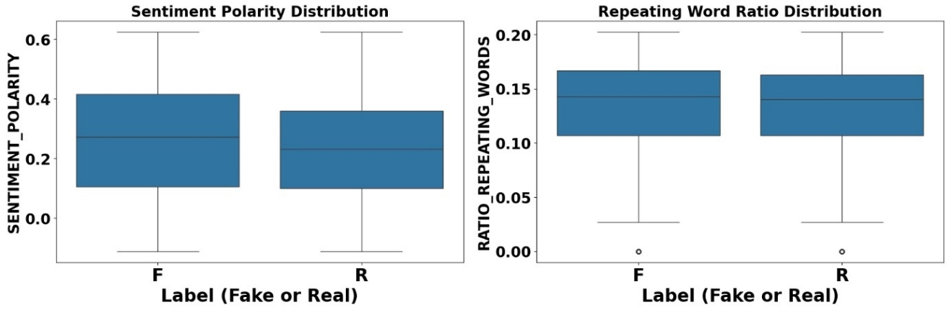

**Figure 5) Boxplots for the distribution of sentiment polarity and the ratio of repeating words in fake and real reviews.**

Higher sentiment polarity in fake reviews indicates a tendency towards exaggerated positivity, which could be a tactic to make the review more convincing and appealing. This exaggerated positivity might be used to sway potential buyers by presenting an overly favourable impression of the product or service.

Similarly, the increased ratio of repeating words in fake reviews points to a strategy of reinforcing specific terms or phrases. This repetition can make the review seem more substantial and impactful, further contributing to its perceived credibility.

Figure 6 represents the boxplots for review length and FK score distribution in both fake and real reviews. The boxplots for review length indicate notable differences between real and fake reviews in terms of their distribution and range. Specifically, real reviews exhibit a wider distribution and a higher range compared to fake reviews. The interquartile range (IQR) for real reviews is larger, suggesting greater variability in the length of these reviews. This diversity may reflect the varied nature of genuine user experiences and the different levels of detail that real users provide.

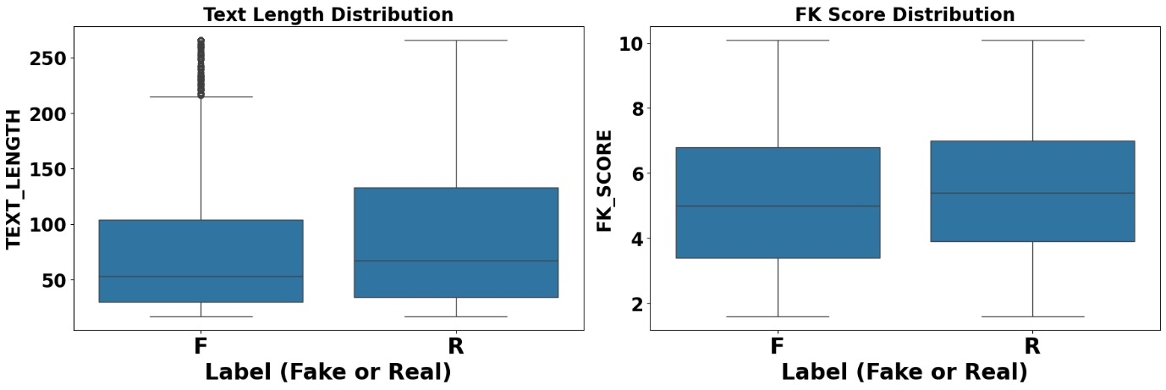

**Figure 6) Boxplots for the distribution of text length and the FK score in fake and real reviews.**

The higher range in real reviews indicates that, on average, real reviews are typically longer than fake ones, suggesting that real users are more likely to write extensive and detailed reviews. This extensive detail is less commonly found in fake reviews, which are often shorter and less detailed, possibly to avoid detection or because they are generated by automated systems. The constrained distribution and lower range in fake reviews suggest a pattern of uniformity and brevity, indicative of automated review generation or the use of templates. The absence of lengthy, detailed reviews in this category further reveals the artificial nature of these reviews.

The box plot for the FK score indicates that real reviews have higher scores compared to fake reviews. This suggests that real reviews tend to have more complex readability levels, which could be attributed to the natural diversity in writing styles among genuine users. Real reviews might include a mix of more complex sentences, reflecting authentic experiences and varying levels of writing proficiency. In contrast, fake reviews may be crafted in simpler language, resulting in more uniform and straightforward text.

As shown in Figure 7, the bar chart for the product name mention feature reveals that the total count is higher for fake reviews. This suggests that fake reviews are more likely to include the product name within the review text, possibly as a tactic to appear more detailed and legitimate. Mentioning the product name could be an intentional strategy to mimic the behaviour of genuine reviews, which might naturally include the product name when discussing specific aspects or experiences.

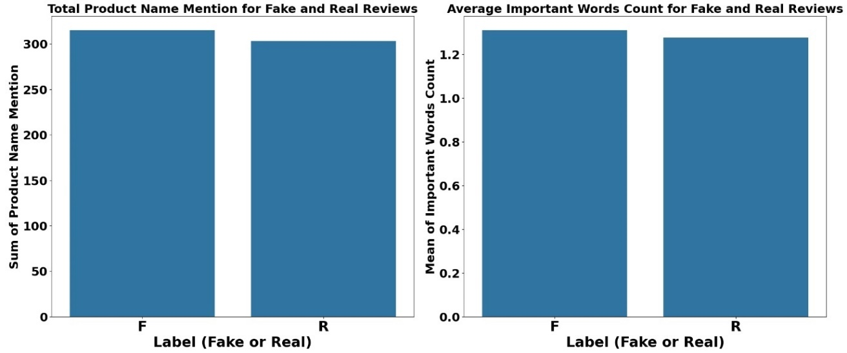

**Figure 7) Bar charts for total product name mention and average important words count in fake and real reviews.**

The bar chart for the IMPORTANT_WORDS_COUNT feature reveals that the average count of important words is higher in fake reviews. This implies that fake reviews might use certain key words more frequently in an effort to sound convincing and positive. These important words, identified through feature engineering, are likely chosen to make fake reviews seem more impactful and persuasive.

1. **Methodology**
   1. **Data Collection and Initial Exploration**

Figure 8 presents a schematic flowchart of the research steps undertaken in this study. The initial step was collecting relevant datasets through web scraping. Datasets were sourced from various platforms, including Amazon, Yelp, and specialized domains such as hotel and restaurant reviews. The initial exploration involved evaluating the structure, content, and indicators of review authenticity within these datasets to ensure their suitability for analysis.

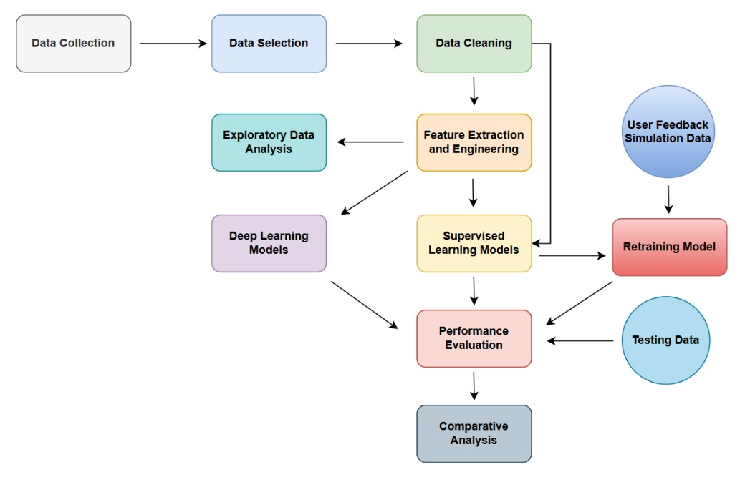

**Figure 8) Framework for the proposed methodology.**

* 1. **Data Cleaning Process and Dataset Creation**

The data cleaning phase involved removing irrelevant or redundant columns, renaming columns for consistency, and standardizing review labels to ‘F’ for fake and ‘R’ for real. Rows without review text, essential for authenticity analysis, were discarded, and duplicates were removed to maintain data uniqueness. This process ensured the data was in a standardized format and ready for further analysis.

A subset of fake reviews was selected to simulate user feedback, which aimed to test and enhance model adaptability through subsequent retraining phases, serving as a proxy for actual user responses.

A balanced sampling approach was applied to both real and fake reviews from each dataset, ensuring diversity in the final dataset. To assess the balance between real and fake reviews, the label distribution was examined. These sampled subsets were then merged to create a comprehensive and unique dataset representing various user-generated content across multiple e-commerce platforms. This balanced approach addressed a significant gap identified in previous research, providing a more diverse and representative dataset for analysis (Alsubari et al., 2021; Soldner et al., 2022).

* 1. **Feature Extraction and Engineering**

The feature engineering process began with calculating straightforward yet informative attributes directly from the review texts. These attributes included review text length, sentiment polarity, Flesch-Kincaid score, and counts of stopwords, capitalizations, and punctuations. A custom function named "Product Name Mention" was developed to detect whether the product's name was mentioned within the review text. This feature was designed to evaluate the review's relevance and specificity concerning the product.

A key aspect of the feature engineering process involved utilizing a Random Forest classifier in conjunction with a CountVectorizer to identify keywords crucial for predicting review authenticity. The top ten keywords were visualized for their relevance, as shown in Figure 9. Six words (great, good, like, love, really, and quality) were selected due to their generic relevance across different datasets. This selection led to the creation of the IMPORTANT_WORDS_COUNT feature, which aggregates the frequency of these words within each review.

Another innovative feature, RATIO_REPEATING_WORDS, was engineered to measure redundancy within review texts. This metric was calculated using the formula:

$$Ratio of Repeating Words=\frac{Count of repeating words}{Total word count in a review}$$

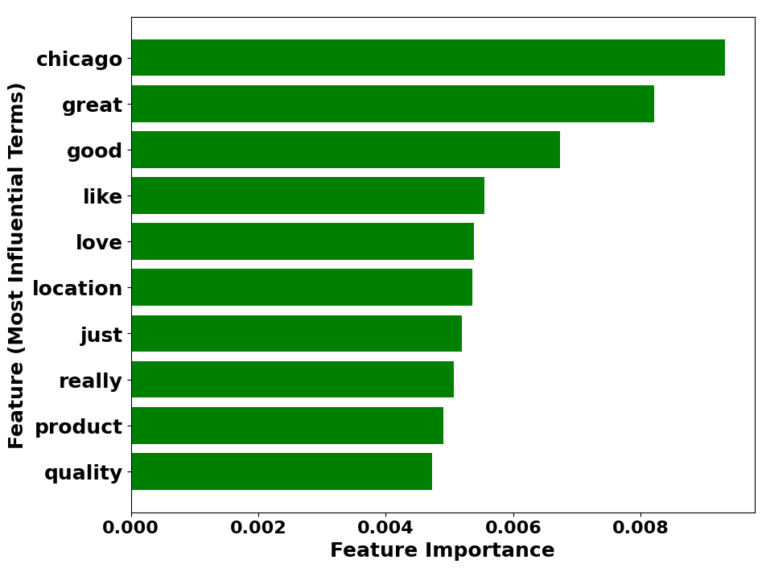

**Figure 9) Top 10 most influential terms identified using a Random Forest classifier.**

This proportion of words repeated more than once offers insights into the originality and potential spamminess of the content. By normalizing this ratio for the length of the review, it provides an unbiased measure of repetitiveness, independent of the review's overall length.

* 1. **Dataset Preprocessing and Supervised Model Training**

The dataset underwent a thorough preprocessing routine to standardize the review text. This involved the removal of non-word characters, conversion of text to lowercase, and the application of lemmatization and stop-word filtering. Such preprocessing was crucial to ensure the uniformity of the textual data, thereby facilitating more accurate model training and prediction.

**Table 1) Preprocessing Steps for Each Feature Type.**

|  |  |
| --- | --- |
| **Feature Type** | **Preprocessing Step** |
| Numeric | Scaling and Median Imputation |
| Categorical | Constant Imputation and One-Hot Encoding |
| Textual | TF-IDF Vectorization |

A pipeline was established for model training, incorporating specific preprocessing steps tailored for numeric, categorical, and textual features. The preprocessing steps for each feature type are summarized in Table 1. This preprocessing pipeline ensured that each feature type was appropriately handled, enhancing the models' learning efficacy (Nguyen, 2023).

Based on previous research exploring various machine learning approaches for detecting fake reviews, this study compared four methods including KNN, SVM, RF, and LR using a cross-platform dataset to determine the most suitable model for broad applicability (Nguyen, 2023; Sajid et al., 2023; Mohawesh et al., 2021).

As part of the modelling process, the GridSearchCV technique was employed along with 5-fold cross-validation for several key purposes:

* **Optimal Hyperparameter Selection**: This technique systematically explored various hyperparameters, such as the number of neighbors in KNN or the regularization strength in Logistic Regression, to identify the best-performing parameter combinations.
* **Model Validation**: Cross-validation was crucial for assessing model generalizability to unseen data, helping to prevent overfitting by validating the model across multiple dataset partitions.
* **Performance Stability**: This method provided insights into the model's consistency across different data subsets, indicating stability and reliability.
* **Model Benchmarking**: Using cross-validation with GridSearchCV enabled fair comparisons by evaluating models under the same conditions, ensuring unbiased performance metrics.
* **Resource Efficiency**: The integration of hyperparameter tuning and model validation streamlined the model development process, optimizing resource use and time (Bischl et al., 2023).

Through this preprocessing and model training process, the study aimed to develop accurate and generalizable models for detecting fake reviews, leveraging the strengths of both traditional machine learning techniques and advanced hyperparameter optimization methods.

* 1. **Performance Evaluation**

After training, each model's performance was evaluated using key metrics such as accuracy, precision, recall, and F1 score. Confusion matrices were also generated to provide deeper insights into the models' abilities to distinguish between fake and real reviews, showing prediction accuracies across different classes.

In this study, the focus was on detecting fake reviews. Therefore, True Positives (TP) are defined as fake reviews correctly identified as fake. The metrics used for performance evaluation were defined as follows:

* **Accuracy**: The proportion of true results (both true positives and true negatives) among the total number of cases examined.
$$Accuracy=\frac{TP+TN}{TP+TN+FP+FN}$$

* **Precision**: The ratio of true positive results to the total number of positive predictions made by the model.
$$Precision=\frac{TP}{TP+FP}$$

* **Recall**: The ratio of true positive results to the total number of actual positives in the dataset.
$$Recall=\frac{TP}{TP+FN}$$

* **F1 Score**: The harmonic mean of precision and recall, providing a balance between the two metrics.

$$F1 Score=2×\frac{Precision×Recall}{Precision+Recall}$$

Where:

* TP denotes True Positives: Fake reviews correctly identified as fake.
* TN denotes True Negatives: Real reviews correctly identified as real.
* FP denotes False Positives: Real reviews incorrectly identified as fake.
* FN denotes False Negatives: Fake reviews incorrectly identified as real.

To further validate the models, a separate test set comprising 400 fake and 400 real reviews was utilized to verify the models' performance on unseen data. This step ensured that the models could generalize well beyond the training data.

Additionally, a version of the dataset without the engineered features was subjected to the same preprocessing and modelling procedures. This allowed for a direct comparison of performance metrics to determine the efficacy of the feature engineering process.

These comprehensive metrics offered a detailed evaluation of each model's performance. The use of test sample aimed to evaluate whether the models could maintain their performance on unseen data, highlighting the effectiveness of the feature engineering efforts and the overall modelling approach.

* 1. **Integration of Simulated User Feedback**

A novel aspect of this study was the integration of simulated user feedback into the dataset, designed to test the models' adaptability and improvement over time. This simulated feedback, posed a challenge to the models, compelling them to refine their prediction strategies. By retraining the models with this augmented dataset, their ability to evolve in response to new information was assessed, mirroring real-world scenarios where models must continually adapt to emerging patterns.

After incorporating the simulated user feedback, the models underwent a second round of training and evaluation using the same performance metrics and hyperparameter optimization techniques. This iterative process of refinement was essential for evaluating the models' capability to enhance their predictive accuracy over time, thereby ensuring their accuracy and reliability in detecting fake reviews in dynamic online environments.

* 1. **Deep Learning Model Development**

As the final step of this project, three primary neural network architectures were developed and evaluated: Long Short-Term Memory (LSTM), Convolutional Neural Network combined with LSTM (CNN-LSTM), and a hybrid LSTM-Recurrent Neural Network (LSTM-RNN). The choice of these methods was based on recent literature, as researchers have successfully employed these architectures for fake review detection (Vyas et al., 2021; Mohawesh et al., 2024).

The dataset was prepared by tokenizing the review text and converting it into sequences of integers, followed by padding to ensure uniform input length. The review labels were encoded using a label encoder. The LSTM model featured an embedding layer, two LSTM layers with dropout for regularization. The CNN-LSTM model combined convolutional layers for extracting local features with LSTM layers to capture sequence information. The LSTM-RNN model included LSTM layers followed by a SimpleRNN layer to leverage both long-term and short-term dependencies in the data.

Each model was included precision and recall metrics for a comprehensive performance evaluation. Early stopping was employed to prevent overfitting, using validation loss monitoring. The models were trained using a validation split and subsequently evaluated on the test set to determine their performance metrics.

These deep learning methods were selected as basic approaches to compare their performance with the previously developed supervised models. This comparison aims to evaluate the effectiveness of deep learning techniques in detecting fake reviews and to determine if they offer significant advantages over traditional supervised learning methods.

1. **Results and Discussion**

This chapter presents the accuracy and other performance metrics for the models discussed in the Methodology chapter (Chapter 5). It provides a comprehensive analysis of the results, including a comparison of supervised model performances with and without feature engineering, the impact of simulated user feedback, and the efficacy of deep learning models versus supervised models. This discussion aims to interpret the implications of these findings in the context of fake review detection across various e-commerce platforms.

* 1. **Performance Results of Supervised Models**

The selection of the most appropriate models was conducted through GridSearchCV, employing a 5-fold cross-validation strategy to optimize the models' hyperparameters and assess their effectiveness across multiple data partitions. Table 2 shows the cross-validation accuracy and optimal hyperparameters for each of the supervised models.

**Table 2) Cross-validation accuracy and optimal hyperparameters for supervised models.**

|  |  |  |
| --- | --- | --- |
| **Model** | **Cross-Validation Accuracy** | **Optimal Hyperparameters** |
| KNN | 0.7637 | 7 Neighbors |
| SVM | 0.7995 | RBF Kernel, C = 1 |
| RF | 0.7952 | 200 Estimators, No Maximum Depth |
| LR | 0.7894 | Regularization Strength C = 0.1 |

The initial performance metrics (Accuracy, Precision, Recall, and F1 Score) results of the four supervised models is visualized in Figure 10. Despite RF showing robust cross-validation performance, SVM emerged as the leader in actual test performance, closely followed by LR. This shift underscores the influence of the test dataset's unique characteristics, which may favour the boundary complexities handled by SVM.

The differences in performance highlight how the models' generalization may not uniformly extend from cross-validation to unseen data, influenced by the distinct nature of the test set. While RF's complexity allowed it to excel in a controlled cross-validation setup, SVM's ability to effectively manage non-linear patterns gave it an edge in real-world applicability on the test set. The precision, recall, and F1 scores of SVM suggest its superior ability to manage trade-offs between error types effectively, a critical aspect in practical scenarios.

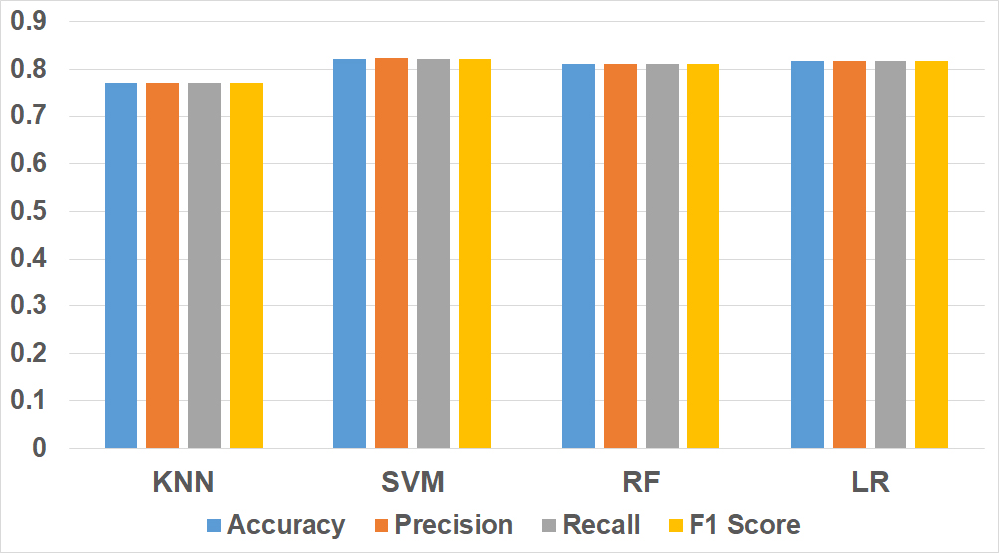

**Figure 10) Visualization of the performance metrics results for supervised models.**



**Figure 11) Confusion matrix results for supervised models.**

Figure 11 shows the confusion matrix results of the four supervised models. SVM not only showed a lower rate of false positives than the other models but also achieved a high number of true positives and true negatives. This performance indicates SVM's effectiveness in handling non-linear patterns, which likely led to its superior results on the test dataset. Logistic Regression (LR) also performed well, with a significant number of true positives and the fewest false positives, reflecting its high recall and precision scores. Both RF and KNN were competitive, though their performance was slightly below that of SVM and LR. RF excelled in identifying fake reviews with the highest number of true positives but had a higher rate of false negatives compared to LR and SVM.

* 1. **Evaluating the Efficacy of Feature Engineering**

The analysis of model performance metrics before and after applying feature engineering reveals interesting insights into the efficacy of feature enhancements (Table 3). The results indicate that feature engineering had varying impacts on the different supervised models used in this study.

**Table 3) Relative percentage change in model performance metrics after feature engineering.**

|  |  |  |  |  |
| --- | --- | --- | --- | --- |
| **Model** | **Accuracy (%)** | **Precision (%)** | **Recall (%)** | **F1 Score (%)** |
| KNN | 0.4926 | 0.1813 | 0.4926 | 0.6871 |
| SVM | 3.0852 | 3.2829 | 3.0852 | 3.0635 |
| RF | -0.8426 | -0.8426 | -0.8426 | -0.8426 |
| LR | 0.4672 | 0.4547 | 0.4672 | 0.4672 |

For the KNN, SVM, and Logistic Regression models, feature engineering led to improvements across all evaluated metrics. Specifically, the SVM model demonstrated the most significant enhancement, with performance metrics increasing by approximately 3% in most cases. This substantial improvement suggests that the additional features provided more informative and discriminative power, aiding the SVM model in better distinguishing between fake and real reviews.

KNN and Logistic Regression also benefited from feature engineering, though to a lesser extent than SVM. The slight increases in their performance metrics indicate that the newly engineered features contributed positively to the models’ ability to capture relevant patterns in the data, albeit not as dramatically as for SVM.

Conversely, the Random Forest model experienced a slight decrease in performance metrics following feature engineering. This unexpected result might be due to the introduction of noise or redundant information by the new features, which could have led to overfitting or a reduction in the model's generalizability. RF models are inherently robust due to their ensemble nature, which typically handles feature redundancy well (Alsubari et al., 2021), but in this case, the additional features might have disrupted this balance.

These mixed results highlight an important consideration: the impact of feature engineering can vary significantly depending on the machine learning algorithm in use. While SVM showed notable improvement, suggesting that it effectively leveraged the new features, the decline in RF performance indicates that more features do not always equate to better model performance. This emphasizes the necessity of a customized approach to feature engineering, where the decision to add or modify features should be guided by the specific characteristics and requirements of each modelling method.

Overall, while feature engineering proved beneficial for most models in this study, its application should be method-specific. SVM, in particular, showcased the largest gains, suggesting it can efficiently exploit the added feature information. However, the slight decline in RF performance serves as a cautionary note that feature engineering should be approached with a nuanced understanding of the model's nature and the dataset's intricacies. This tailored approach ensures that feature engineering efforts are effective and conducive to improved model performance.

* 1. **Testing Supervised Models with New Data**

The performance of the supervised models was evaluated using a new test sample consisting of 800 reviews, equally distributed between 400 fake and 400 real reviews. This sample was created by merging rows from two datasets sourced from Amazon. Notably, these reviews pertain to products in different categories from those in the dataset used for creating the models. The aim was to assess how well the models, developed with a cross-platform dataset, perform with new and unseen data. The same feature engineering steps were applied to ensure consistency in the features used for testing.

Table 4 presents the performance metrics for the models against the new test dataset. Each model demonstrated commendable accuracy and reliability in detecting fake reviews within the new dataset. The slight decline in performance compared to the initial results is expected, given the new and unseen dataset with different product types. These results demonstrate the models' strong ability to generalize to new data, suggesting that they can be effectively used across different e-commerce platforms. The consistent performance, despite a slight decline, highlights the reliability and adaptability of these models when applied to new and unseen datasets.

Interestingly, the Random Forest model showed better performance on the test dataset compared to the other models, unlike the initial modelling phase where SVM was the top performer. This discrepancy could be attributed to the nature of the test dataset, which is smaller and less diverse than the initial dataset. RF, with its ensemble approach, might be more robust in handling smaller datasets due to its ability to capture complex patterns through multiple decision trees. This capability allows RF to adapt better to the specific characteristics of the new test data, whereas SVM might excel more in larger, more varied datasets where its ability to manage non-linear patterns can be fully leveraged efficacy (Alsubari et al., 2021; Nguyen, 2023).

**Table 4) Performance metrics of supervised models on the new test dataset.**

|  |  |  |  |  |
| --- | --- | --- | --- | --- |
| **Model** | **Accuracy** | **Precision** | **Recall** | **F1 Score** |
| KNN | 0.7288 | 0.7312 | 0.7288 | 0.7280 |
| SVM | 0.7725 | 0.7729 | 0.7725 | 0.7724 |
| RF | 0.7950 | 0.8060 | 0.7950 | 0.7931 |
| LR | 0.7600 | 0.7632 | 0.7600 | 0.7593 |

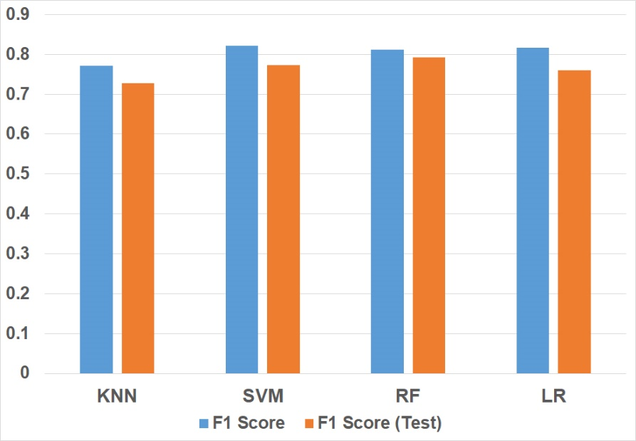

**Figure 12) Comparison of initial and test set F1 scores for the four supervised models.**

Figure 12 presents a comparison of the initial and test set F1 scores of the four models, illustrating their performance stability and generalizability. This ability to generalize and maintain performance across different datasets is crucial for maintaining the integrity of online reviews and ensuring that consumers can trust the authenticity of the feedback they encounter.

* 1. **Performance of Supervised Models after Retraining with Simulated User Feedback**

Following the incorporation of simulated user feedback, the models were retrained to assess their adaptability and improvement over time. The performance metrics post-retraining depicted in Figure 13. The results indicate that all models either maintained or slightly improved their performance after incorporating the simulated feedback. This outcome highlights the models' adaptability and resilience, showcasing their ability to effectively integrate new data and enhance their predictive accuracy.

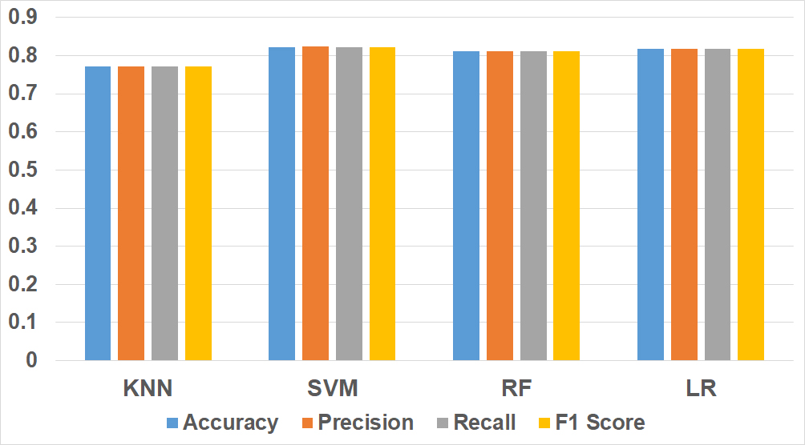

**Figure 13) Bar charts of performance metrics for supervised models after incorporating simulated user feedback.**

Figure 14 illustrates the confusion matrix results after retraining supervised models with simulated user feedback data. SVM effectively balances sensitivity (true positive rate) and specificity (true negative rate), making it particularly suitable for scenarios where minimizing both types of errors is crucial. This reinforces its leading position among the evaluated models.

The consistent performance of SVM, both initially and after retraining, highlights its potential for real-world applications where adaptability is essential. This retraining process showcases the importance of continuous model evaluation and adjustment, ensuring that the detection systems remain effective in dynamic and real-world environments.



**Figure 14) Confusion matrix of supervised models after retraining with simulated user feedback data.**

* 1. **Comparison of Deep Learning and Supervised Models**

The comparative evaluation of deep learning models (LSTM, CNN-LSTM, and LSTM-RNN), introduced earlier in Section 5.7, against previously developed supervised models (KNN, SVM, RF, and LR) reveals several critical insights into the dynamics of model performance in the context of fake review detection. Figure 15 represents a comparison of the performance metrics results between the deep learning models and the SVM model. The results indicate that they did not outperform the supervised models in this specific application.

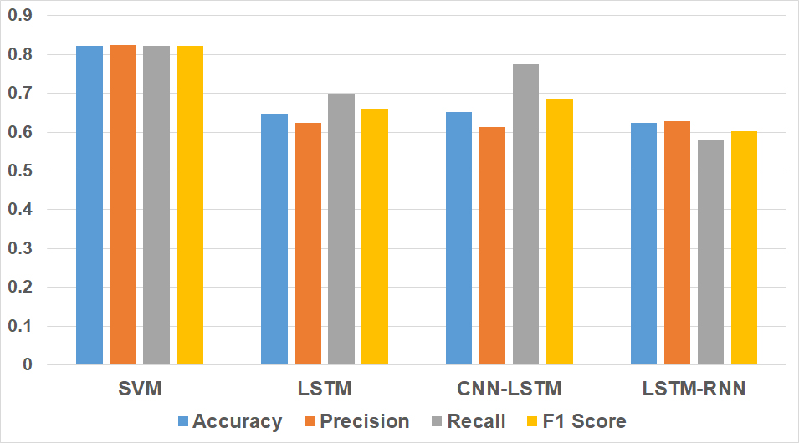

**Figure 15) Comparison of performance metrics for SVM and deep learning models.**

The performance metrics of the LSTM model yielded an F1 Score of 0.6589. By incorporating convolutional layers to capture spatial dependencies, the CNN-LSTM model demonstrated a modest improvement with an F1 Score of 0.6849. The LSTM-RNN model, which combines LSTM and RNN layers to capture both long-term and short-term dependencies, achieved an F1 Score of 0.6025. While these scores are commendable, they fall short of the precision and accuracy demonstrated by the supervised models, particularly the SVM model, which achieved the highest metrics among the supervised models.

This disparity in performance can be attributed to several factors. Despite their powerful feature extraction capabilities, deep learning models may require substantially larger datasets to learn effectively from raw text data without specific feature engineering. They generally thrive on large and diverse datasets (Dean et al., 2012; Mohawesh et al., 2024). In this study, the dataset, while diverse in terms of sources, may still be relatively small and homogenous compared to the vast amounts of data typically required to fully leverage deep learning models. This limitation likely impacted the effectiveness of the deep learning models in this application.

Supervised models, on the other hand, were better suited to the dataset size and complexity. The feature engineering process provided more focused and relevant input, enhancing their performance. These models excel at using explicit features tailored to the specific problem, which helped them generalize better on the test dataset.

While deep learning models are capable of capturing complex patterns, they are also prone to overfitting, particularly without extensive hyperparameter tuning and regularization. This overfitting can result in poorer generalization on unseen data compared to simpler supervised models (Srivastava et al., 2014). The supervised models, benefiting from feature engineering, managed to generalize better on the test dataset.

Additionally, deep learning models are resource-intensive, requiring longer training times and more computational power. However, this increased complexity does not always correlate with better performance. The supervised models, with their relatively simpler architectures, delivered competitive performance with less computational overhead.

These findings indicate the continued relevance and efficiency of supervised learning models in scenarios like detecting fake reviews. These models not only perform competitively but also do so with less computational overhead and greater interpretability compared to their deep learning counterparts.

While deep learning offers promising avenues, especially for large-scale and unstructured datasets, its effectiveness in the context of fake review detection should be carefully weighed against the complexity of model tuning and resource allocation. This study thus serves as a foundation for future explorations into optimizing the balance between model complexity and performance, paving the way for more sophisticated approaches in the ongoing battle against fake reviews. By understanding the strengths and limitations of each modelling approach, practitioners can make informed decisions about the most appropriate techniques to deploy in their specific contexts.

1. **Conclusion**

The findings of this study highlight the crucial role of machine learning in maintaining the credibility of online reviews, which are essential for informed consumer decisions. By leveraging a multi-faceted approach that integrates both traditional supervised models and deep learning techniques, this research provides valuable insights into effectively identifying and filtering out fake reviews on digital platforms.

Based on extensive web searches conducted in this project, all freely available labelled fake review datasets were utilized to create a unique and diverse cross-platform dataset, which stands as a highlight and strength of this work. Prior research on fake review detection has frequently demonstrated high performance; however, these models were predominantly trained and evaluated on datasets from a single e-commerce platform (Nguyen, 2023; Sajid et al., 2023). While these models perform well within their specific contexts, their ability to generalize across different datasets is limited, making them prone to overfitting. Conversely, this project enhances the strength and versatility of detection models by utilizing a cross-platform dataset aggregated from multiple sources. This strategy not only reduces the likelihood of overfitting but also ensures that the developed models are adaptable and effective across a variety of e-commerce platforms.

The comparative evaluation indicates that the SVM model exhibited the most consistent and superior performance across all assessed metrics. This result not only confirms the efficacy of SVM in scenarios requiring significant adaptability but also highlights the importance of selecting appropriate kernel functions and regularization parameters to enhance model precision. Furthermore, testing with a separate dataset affirmed the models' capability to generalize well to new, unseen data, with RF achieving the highest accuracy and overall performance.

Feature engineering's impact was a critical aspect of this project, assessed by comparing model performance with and without these features. While the improvements were modest overall, SVM's accuracy increased by approximately 3%, making it the top-performing model due to this boost. LR and KNN saw improvements of less than 1%, and RF's performance slightly decreased by less than 1%. Although the overall impact was not drastic, the close performance metrics of the models indicate that feature engineering played a significant role in SVM emerging as the best model. This result suggests that the utility of feature engineering depends on the specific model and dataset, and it is not always beneficial. In some cases, such as with the RF model, it can add unnecessary complexity and even slightly decrease performance.

The comparative study of three deep learning models, including LSTM, CNN-LSTM, and LSTM-RNN, with the supervised models revealed that despite their sophisticated architectures and ability to capture complex patterns, the deep learning models did not outperform the supervised models in this specific application. This highlights the importance of context-specific model selection, demonstrating that simpler supervised models can be more effective for detecting fake reviews depending on the dataset's characteristics, as seen in this project.

The incorporation of simulated user feedback demonstrated the models' ability for ongoing improvement, with SVM continuing to outperform other models in performance metrics. The capacity of SVM and RF to maintain and even slightly enhance their performance after retraining indicates that these models, when optimally adjusted, can achieve both high accuracy and flexibility in ever-changing environments.

In conclusion, this project has demonstrated the efficacy of machine learning techniques in detecting fake reviews, emphasizing the significance of cross-platform datasets, feature engineering, and continuous model adaptation. The findings suggest that while deep learning offers potential, supervised models remain highly effective and efficient for this task, providing a solid foundation for future research and practical applications in maintaining consumer trust in online reviews.

1. **Future Work and Recommendations**

Several avenues for future research can further enhance fake review detection and improve the performance of machine learning models:

* **Expand Dataset Diversity**: Collect and integrate more diverse datasets across various e-commerce platforms and product categories to build more generalizable models.
* **Integrate Metadata**: Incorporate additional metadata such as reviewer history, product characteristics, and temporal review patterns to improve detection accuracy.
* **Hybrid Models**: Combine supervised and deep learning models through hybrid approaches, leveraging ensemble methods and integrating deep learning with traditional feature engineering for enhanced performance.
* **Real-Time Detection**: Develop real-time systems to flag suspicious reviews as they are posted, with continuous incremental learning for improved accuracy.
* **User Feedback Integration**: Create interactive platforms for users to provide feedback on review authenticity, promoting greater user engagement and model refinement.

Pursuing these recommendations will drive advancements in fake review detection, contributing to the integrity and reliability of online review systems.

“Word Count: 7485”

**Bibliography**

* *Abi Priya, M., Hema, S., Dhivya Praba, R. (2020) Fake Product Review Monitoring and Removal for Genuine Online Product Review Using IP Address Tracking. International Journal of Advanced Research in Electrical, Electronics and Instrumentation Engineering, 9, Available at:* [*https://www.researchgate.net/publication/355843276*](https://www.researchgate.net/publication/355843276) *[Accessed 17 February 2024].*
* *Duma, R.A., Niu, Z., Nyamawe, A.S., Tchaye-Kondi, J., Jingili, N., Yusuf, A.A., Deve, A.F. (2024) Fake review detection techniques, issues, and future research directions: a literature review, Knowledge and Information Systems. Available at:* [*https://doi.org/10.1007/s10115-024-02118-2*](https://doi.org/10.1007/s10115-024-02118-2) *[Accessed 8 July 2024].*
* *Nguyen, N. (2023) An Empirical Study on Fake Review Detection. Travinh University Journal of Science [online]. 13(Special Issue), pp. 1-10. Available at:* [*https://doi.org/10.35382/TVUJS.13.6.2023.2107*](https://doi.org/10.35382/TVUJS.13.6.2023.2107) *[Accessed 17 February 2024].*
* *Sajid, T., Jamshed, W., Kumar Goyal, N., Keswani, B., Cieza Altamirano, G., Goyal, D., Keswani, P. (2023) Analysis and Challenges in Detecting the Fake Reviews of Products using Naïve Bayes and Random Forest Techniques. [online]. Available at:* [*https://doi.org/10.21203/rs.3.rs-2302761/v1*](https://doi.org/10.21203/rs.3.rs-2302761/v1) *[Accessed 17 February 2024].*
* *Joghee, P. (2022) Classification and Analysis of Fake Product Review using AI. Telematique [online]. 21, pp. 4970-4977. Available at:* [*https://www.researchgate.net/publication/364956956*](https://www.researchgate.net/publication/364956956) *[Accessed 17 February 2024].*
* *Soldner, F., Kleinberg, B., Johnson, S.D. (2022) Confounds and overestimations in fake review detection: Experimentally controlling for product-ownership and data-origin. PLoS ONE [online]. 17(12). Available at:* [*https://doi.org/10.1371/journal.pone.0277869*](https://doi.org/10.1371/journal.pone.0277869) *[Accessed 17 February 2024].*
* *Salminen, J., Kandpal, C., Kamel, A.M., Jung, S.-g., Jansen, B.J. (2022) Creating and detecting fake reviews of online products. Journal of Retailing and Consumer Services [online]. 64. Available at:* [*https://doi.org/10.1016/j.jretconser.2021.102771*](https://doi.org/10.1016/j.jretconser.2021.102771) *[Accessed 17 February 2024].*
* *Alsubari, S.N., Deshmukh, S.N., Alqarni, A.A., Alsharif, N., Aldhyani, T.H.H., Alsaade, F.W., Khalaf, O.I. (2021) Data Analytics for the Identification of Fake Reviews Using Supervised Learning. Computers, Materials & Continua [online]. Available at:* [*https://doi.org/10.32604/cmc.2022.019625*](https://doi.org/10.32604/cmc.2022.019625) *[Accessed 17 February 2024].*
* *Wang, Z., Zhang, Y. and Qian, T. (2017) Fake Review Detection on Yelp. Available at:* [*https://cs229.stanford.edu/proj2017/final-reports/5229663.pdf*](https://cs229.stanford.edu/proj2017/final-reports/5229663.pdf) *[Accessed 17 February 2024].*
* *Mohawesh, R., Al-Hawawreh, M., Maqsood, S., Alqudah, O. (2023) Factitious or fact? Learning textual representations for fake online review detection. Cluster Computing [online]. Available at:* [*https://doi.org/10.1007/s10586-023-04148-x*](https://doi.org/10.1007/s10586-023-04148-x) *[Accessed 17 February 2024].*
* *Mohawesh, R., Xu, S., Tran, S.N., Ollington, R., Springer, M., Jararweh, Y., Maqsood, S. (2021) Fake Reviews Detection: A Survey. IEEE Access [online]. 9. Available at:* [*https://doi.org/10.1109/ACCESS.2021.3075573*](https://doi.org/10.1109/ACCESS.2021.3075573) *[Accessed 17 February 2024].*
* *Zaki, N., Krishnan, A., Turaev, S., Rustamov, Z., Rustamov, J., Almusalami, A., Ayyad, F., Regasa, T., Iriho, B.B. (2023) Node Embedding Approach for Accurate Detection of Fake Reviews: A Graph-Based Machine Learning Approach with Explainable AI. [online]. Available at:* [*https://doi.org/10.21203/rs.3.rs-2841712/v1*](https://doi.org/10.21203/rs.3.rs-2841712/v1) *[Accessed 17 February 2024].*
* *Mewada, A., Dewang, R.K. (2022) Research on false review detection Methods: A state-of-the-art review. Journal of King Saud University – Computer and Information Sciences [online]. 34, pp. 7530–7546. Available at:* [*https://doi.org/10.1016/j.jksuci.2021.07.021*](https://doi.org/10.1016/j.jksuci.2021.07.021) *[Accessed 17 February 2024].*
* *Shaik Vadla, M.K., Agumbe Suresh, M., Viswanathan, V.K. (2024) Enhancing Product Design through AI-Driven Sentiment Analysis of Amazon Reviews Using BERT. Algorithms, 17, 59. Available at:* [*https://doi.org/10.3390/a17020059*](https://doi.org/10.3390/a17020059) *[Accessed 8 July 2024].*
* *Mohawesh, R., Salameh, H.B., Jararweh, Y., Alkhalaileh, M. and Maqsood, S. (2024) Fake review detection using transformer-based enhanced LSTM and RoBERTa. International Journal of Cognitive Computing in Engineering, 5, pp. 250-258. Available at:* [*https://doi.org/10.1016/j.ijcce.2024.06.001*](https://doi.org/10.1016/j.ijcce.2024.06.001) *[Accessed 8 July 2024].*
* *Vyas, P., Liu, J. and El-Gayar, O. (2021) Fake News Detection on the Web: An LSTM-based Approach. Americas Conference on Information Systems (AMCIS). Available at:* [*https://scholar.dsu.edu/bispapers/267355843276*](https://scholar.dsu.edu/bispapers/267355843276) *[Accessed 8 July 2024].*
* *Hajek, P., Barushka, A. and Munk, M. (2020) Fake consumer review detection using deep neural networks integrating word embeddings and emotion mining. Neural Computing and Applications, 32, pp. 17259–17274. Available at:* [*https://doi.org/10.1007/s00521-020-04757-2*](https://doi.org/10.1007/s00521-020-04757-2) *[Accessed 8 July 2024].*
* *Qayyum, H., Ali, F., Nawaz, M. and Nazir, T. (2023) FRD-LSTM: a novel technique for fake reviews detection using DCWR with the Bi-LSTM method. Multimedia Tools and Applications, 82, pp. 31505–31519. Available at:* [*https://doi.org/10.1007/s11042-023-15098-2*](https://doi.org/10.1007/s11042-023-15098-2) *[Accessed 8 July 2024].*
* *Bischl, B., Binder, M., Lang, M., Pielok, T., Richter, J., Coors, S., Thomas, J., Ullmann, T., Becker, M., Boulesteix, A-L., Deng, D., & Lindauer, M., 2023. Hyperparameter optimization: Foundations, algorithms, best practices, and open challenges. WIREs Data Mining and Knowledge Discovery, 13(2). Available at:* [*https://doi.org/10.1002/widm.1484*](https://doi.org/10.1002/widm.1484) *[Accessed 8 July 2024].*
* *Dean, J., Corrado, G., Monga, R., Chen, K., Devin, M., Le, Q. V., Mao, M. Z., Ranzato, M., Senior, A., Tucker, P., Yang, K., & Ng, A. Y., 2012. Large scale distributed deep networks. In: Advances in neural information processing systems. pp.1223-1231. Available at:* [*https://www.researchgate.net/publication/266225209*](https://www.researchgate.net/publication/266225209) *[Accessed 8 July 2024].*
* *Srivastava, N., Hinton, G., Krizhevsky, A., Sutskever, I., & Salakhutdinov, R., 2014. Dropout: A simple way to prevent neural networks from overfitting. The journal of machine learning research, 15(1), pp.1929-1958. Available at:* [*https://www.cs.toronto.edu/~rsalakhu/papers/srivastava14a.pdf*](https://www.cs.toronto.edu/~rsalakhu/papers/srivastava14a.pdf) *[Accessed 8 July 2024].*
* *GitHub.com and Kaggle.com for datasets.*

**Appendices**

**Appendix A: Project Evolution and Reflection**

My Initial plan aimed to create a platform where users could search for products and receive a filtered summary of authentic reviews, including a highlights report and average scores. However, after consulting with the supervisor during the project class, it became clear that this idea was too broad for an MSc project. The advice was to narrow the focus to something more specific and manageable within the scope of the data science. Consequently, I refined my approach to concentrate specifically on detecting fake reviews.

Throughout the project, feedback from supervision meetings was instrumental in shaping the direction and quality of the work. These meetings not only guided the refinement of the project scope and structure but also provided critical insights that enhanced the overall rigor and depth of the study. In the first meeting with my individual supervisor, we agreed to base the project on machine learning methods identified in the literature, conducting a comparative evaluation of different models. This initial focus set the foundation for the project. During our third meeting, we decided to incorporate feature engineering efficiency and testing models with new data types into the project. These additions were crucial for addressing the gaps identified earlier in the literature review.

The structure of the report also evolved significantly to enhance clarity and informativeness. Initially, all visualizations were included in the Results and Discussion section. However, to provide readers with a better understanding of the dataset, separate Metadata and Exploratory Data Analysis (EDA) sections were added before the Methodology. This restructuring made the report more coherent and accessible.

Given the changes and additions to the project scope, we also determined that the original title in the proposal was too generic. After discussing the project’s expanded focus, the title was updated to better reflect the various aspects of the work. This new title more accurately captures the project's approach including cross-platform analysis, feature engineering evaluation, and the comparison of supervised and deep learning models.

During the project, several challenges arose that required strategic problem-solving and adaptation. One major obstacle was the integration of diverse datasets from various sources, which involved data cleaning and preprocessing to ensure consistency and compatibility. Additionally, fine-tuning the machine learning models to achieve optimal performance while avoiding overfitting proved to be complex, especially given the diverse characteristics of the datasets. Balancing model complexity with computational efficiency was another challenge, particularly in the deep learning phase, where resource-intensive training processes demanded considerable time and computational power. Despite these challenges, overcoming them contributed to the development of a more refined and comprehensive final project.